**Md. Ratan Ali**

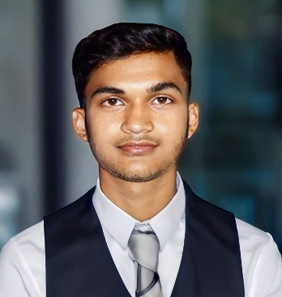

Web Developer & Graphic Designer

**Phone**: +8801601-323433

**Email**: themdratanali@gmail.com

**LinkedIn**: mdratanali | **Behance**: mdratanali | **Github**: themdratanali

**Location**: Hat Ramchandrapur, Paba, Rajshahi-6211, Bangladesh

# **Career Objective**

I I am passionate about Web Development and Graphic Design. With over three years of experience in this field, I have worked with various companies and clients as a Web Developer and Graphic Designer. My goal is to deliver creative, user-friendly, and effective digital solutions that meet client needs and business objectives.

# 

# 

# **Education**

• **Bangladesh Army University of Engineering & Technology** Natore,Rajshahi

*B.Sc. in Computer Science and Engineering (CSE); GPA: -.-- ----/----*

• **Taherpur Degree College** Rajshahi

*Higher Secondary Certificate (HSC)-* *Science; GPA: 5.00* 2020

• **Taherpur River View Girls Highschool** Rajshahi

*Secondary School Certificate (SSC) -* *Science; GPA: 4.91* 2018

*Junior School Certificate (JSC); GPA: 5.00* 2014

# **Skill**

• **UI/UX Design**: Adobe XD, Figma

• **Front-end web development**: HTML, CSS, Bootstraps, JavaScript

• **Back-end web development**: PHP, Laravel

• **Programming language**: C, C++, Python (Intermedia Knowledge)

• **Applications**: Microsoft Word, Microsoft Excel, Microsoft PowerPoint

# **Experience**

**Deppol Tech Agency** Rajshahi,BD

Data Entry2022 – 2023

• Handled various data entry tasks, including copy-pasting, entering product details, converting photos to

text, and organizing data lists. Maintained accuracy and efficiency in all assignments, contributing to

smooth data management processes.

**Projects**

• **Bonolota DreamDorm App:** The Bonolota DreamDorm app is a comprehensive management

solution for Bonolota Hall, enabling staff to manage notices, registrations, and updates, while

providing students with seamless access to hall services.

• **Resume Analyzer**: The Resume Analyzer web application will analyze CVs and provide

actionable insights to users, helping them improve their resumes effectively, using Python and Flask

for development.

• **Job Portal Web**: The job portal web application, developed using PHP and Laravel, streamlines

job search and recruitment processes, connecting employers with qualified candidates effectively.

**Extra-curricular Activities**

• **BAUET-Mind Storm**: I participated in BAUET Mind Storm, a project showcase event, where my team

and I developed an innovative app using Java. Our hard work and creativity paid off, and our project

was recognized for its excellence, earning us the Runner-Up position.

• **Lab AR-Internship**: I completed a 25-day internship at Lab AR, located in the ICT Tower, Bangladesh.

During this time, I worked on multiple website development projects, gaining valuable hands-on

experience in web development and project execution.

# **Personal Information**

**Father’s Name**  : Md. Abdul Mannan Mondol

**Mother’s Name**  : Mst. Hasna Hena

**Address** : Taherpur, Rajshahi-BD

**Date of Birth** : 06 June 2001

**Religion**  : Muslim

**Marital Status**  : Single

**Blood Group**  : O+

**Nationality** : Bangladeshi

**National ID No.** :